**GROCERY WEBAPP USING MERN STACK**

**INTRODUCTION :**

**Grocery-WebApp** is a modern and user-friendly online platform designed to streamline the grocery shopping experience. Whether you are a busy professional, a parent looking for convenience, or anyone in need of household essentials, our web app offers an intuitive, efficient, and secure way to shop for groceries. With a wide range of products available, from fresh produce to pantry staples, snacks, and cleaning supplies, Grocery-WebApp has everything you need—all in one place.

Our goal is to make your online grocery shopping experience simple and enjoyable, whether you’re shopping from your computer or mobile device. We aim to cater to a diverse range of customers, offering easy navigation, a secure payment system, and quick delivery options, ensuring your shopping experience is seamless and hassle-free.

**For Customers:**

At **Grocery-WebApp**, we understand the value of time and convenience. Our platform allows you to easily browse through a variety of product categories, view detailed descriptions, and add your favorite items to your cart—all with just a few clicks. The checkout process is secure, protecting your personal and payment information at all times. Whether you're shopping for your weekly groceries or looking for a last-minute item, **Grocery-WebApp** makes it easy and convenient.

**For Sellers and Administrators:**

Our app also features a robust backend to support sellers and administrators. Sellers can manage their product listings, track inventory, and fulfill orders with ease. Administrators have control over app performance, user management, customer service, and payment processing, ensuring a smooth and efficient experience for both customers and sellers. Our platform is designed to help sellers grow their businesses while maintaining high standards of customer service.

**Key Features of Grocery-WebApp:**

* **User-Friendly Design**: Navigate through a clean, simple, and intuitive interface.
* **Secure Transactions**: Ensure that your payment and personal information is protected at all stages of the transaction.
* **Diverse Product Range**: Shop for everything you need—from fresh produce to snacks, beverages, cleaning products, and more.
* **Efficient Management Tools for Sellers**: Easily manage inventory, product listings, and order fulfillment with comprehensive backend tools.
* **Scalable for Administrators**: Handle customer inquiries, monitor app performance, and manage payments seamlessly.

**Grocery-WebApp** is built with a focus on security, user satisfaction, and convenience. Whether you’re a shopper looking for a quick and safe shopping experience or a seller looking for an efficient platform to manage your store, our app is designed to meet your needs. Join us and make your grocery shopping experience easier, faster, and more enjoyable.

**Architecture**

**Technical Architecture:**

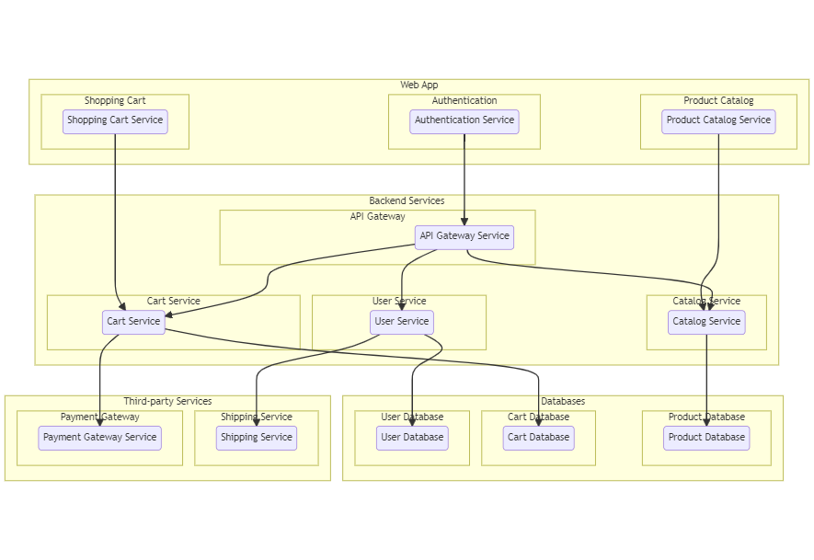

The technical architecture of an flower and gift delivery app typically involves a client-server model, where the frontend represents the client and the backend serves as the server. The frontend is responsible for user interface, interaction, and presentation, while the backend handles data storage, business logic, and integration with external services like payment gateways and databases. Communication between the frontend and backend is typically facilitated through APIs, enabling seamless data exchange and functionality.

**ER Diagram:**

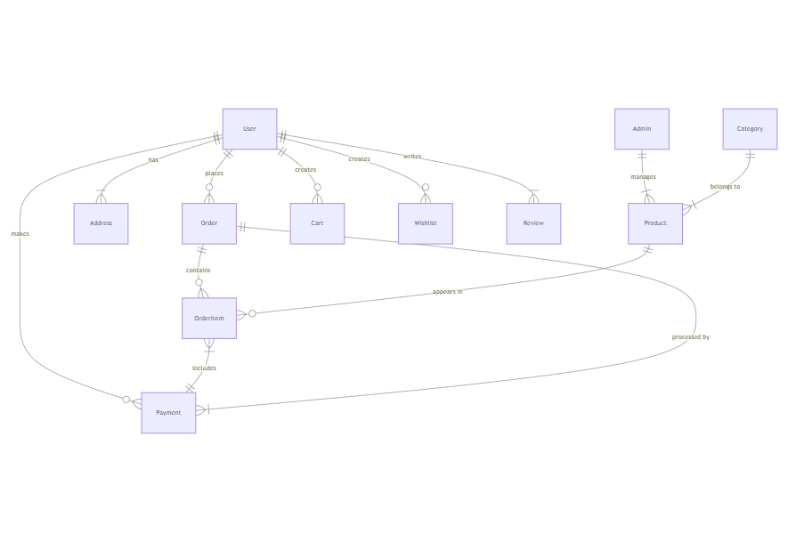The Entity-Relationship (ER) diagram for an flower and gift delivery app visually represents the relationships between different entities involved in the system, such as users, products, orders, and reviews. It illustrates how these entities are related to each other and helps in understanding the overall database structure and data flow within the application.

**Project Structure**

The **Grocery-WebApp** is designed with a modular architecture that ensures scalability, maintainability, and ease of development. Below is an overview of the typical project structure for such an application, including the core components and directories that would make up the app.

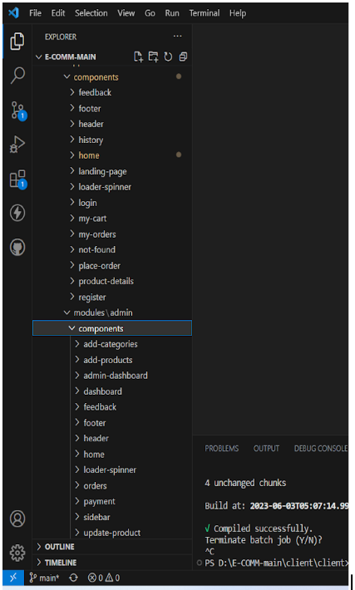

This structure assumes an Angular app and follows a modular approach. Here's a brief explanation of the main directories and files:

* src/app/components: Contains components related to the customer app, such as register, login, home, products, my-cart, my-orders, placeorder, history, feedback, product-details, and more.
* src/app/modules: Contains modules for different sections of the app. In this case, the admin module is included with its own set of components like add-category, add-product, dashboard, feedback, home, orders, payment, update-product, users, and more.
* src/app/app-routing.module.ts: Defines the routing configuration for the app, specifying which components should be loaded for each route.
* src/app/app.component.ts, src/app/app.component.html, `src.

**Role Based Access**

Roles of Admin and User can be defined for an online grocery web application

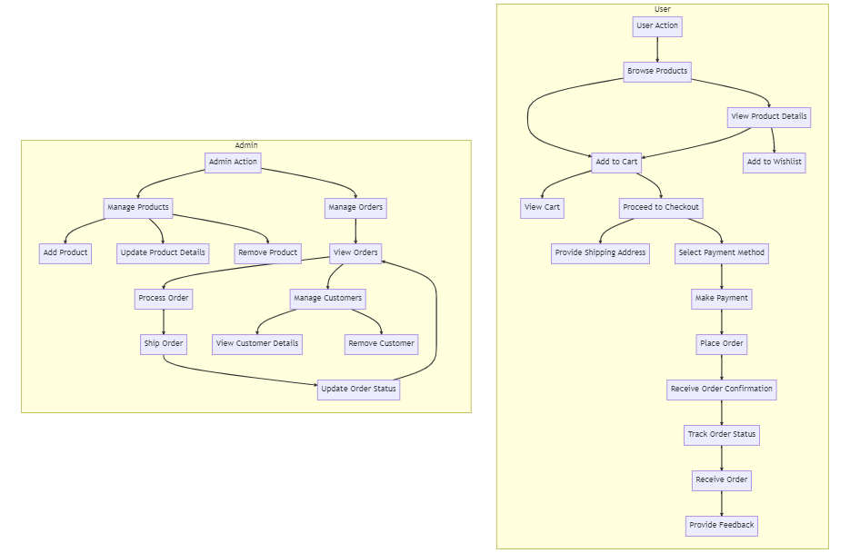

**Admin Role**

1-Admin Role:

* Responsibilities: The admin role has full control and administrative privileges over the system.
* Permissions:
  + Manage: Admins can add, edit, and delete shop information along with products.
  + Manage product bookings: Admins can view and manage all product bookings made by users and agents, including canceling or modifying product bookings.
  + Manage users: Admins can create, edit, and delete user accounts, as well as manage their roles and permissions.
  + Generate reports: Admins have access to generate reports and analytics on product booking details, booking counts, and sales reports.

**User Role**

2-User Role:

* Responsibilities: Users are the customers of the online shopping web application who can search for products, and make product bookings.
* Permissions:
  + View products: Users can search for products, based on interest.
  + Product bookings: Users can select products that are available and complete the order process.
  + Manage product booking: Users can view their own product order bookings, modify booking details, track booking details, and cancel their bookings
  + Manage cart: Users can view their cart details and modify them if needed.

**Project Flow**

* Frontend Development
* Backend Development
* Integration

**Frontend Development**

* Frontend development involves building the user interface (UI) and implementing the visual elements of the online shopping web application. It focuses on creating an intuitive and engaging user experience that allows users to interact with the application seamlessly.

**User Interface (UI) Design**

* Create a visually appealing and consistent design using modern design principles.
* Use a UI design tool like Adobe XD, Sketch, Figma, or InVision to create wireframes and mockups.
* Pay attention to typography, color schemes, spacing, and visual hierarchy.
* Use responsive design techniques to ensure the app looks great on different devices.

**Responsive Design**

* Utilize CSS media queries and responsive design frameworks like Bootstrap or Tailwind CSS to create a responsive layout.
* Test your app on various devices and screen sizes to ensure a seamless user experience.

**Product Catalog**

* Design and implement a product listing page that displays product images, titles, descriptions, prices, and other relevant details.
* Implement search functionality to allow users to find products easily.
* Include filters and sorting options to enhance the browsing experience.

### Backend Development

Backend development involves building the server-side components and logic of the online shopping web application. It focuses on handling the business logic, processing requests from the front end, and interacting with the database. The following activities are part of the backend development process:

**Set Up Backend:**

**Set Up Project Structure:**

* Create a new directory for your project and set up a package.json file using npm init command.
* Install necessary dependencies such as Express.js, Mongoose, and other required packages.

**Database Configuration:**

* Set up a MongoDB database either locally or using a cloud-based MongoDB service like MongoDB Atlas.
* Create a database and define the necessary collections for hotels, users, bookings, and other relevant data.

**Create Express.js Server:**

* Set up an Express.js server to handle HTTP requests and serve API endpoints.
* Configure middleware such as body-parser for parsing request bodies and cors for handling cross-origin requests.

**Define API Routes:**

* Create separate route files for different API functionalities such as hotels, users, bookings, and authentication.
* Define the necessary routes for listing hotels, handling user registration and login, managing bookings, etc.
* Implement route handlers using Express.js to handle requests and interact with the database.

**Implement Data Models:**

* Define Mongoose schemas for the different data entities like hotels, users, and bookings.
* Create corresponding Mongoose models to interact with the MongoDB database.
* Implement CRUD operations (Create, Read, Update, Delete) for each model to perform database operations.

**API Design and Development:**

* Identify the necessary functionality and data required by the frontend.
* Design a set of RESTful APIs using a framework like Express.js or Django REST Framework.
* Define API endpoints for user management, product catalog, shopping cart, order management, payment gateway integration, shipping integration, etc.
* Implement the API routes, controllers, and data models to handle the corresponding operations.
* Ensure that the APIs follow best practices, are secure, and provide appropriate responses.

**User Management and Authentication:**

* Implement user registration and login functionality.
* Choose an authentication mechanism like session-based authentication or token-based authentication (e.g., JWT).
* Store and hash user credentials securely.
* Implement middleware to authenticate API requests and authorize access to protected routes.

**Product Catalog and Inventory Management:**

* Design the database schema to store product details, pricing, availability, and inventory levels.
* Create APIs to retrieve product information, update inventory quantities, and handle search and filtering.
* Implement validations to ensure data integrity and consistency.

**Shopping Cart and Order Management:**

* Design the database schema to store shopping cart details and order information.
* Create APIs to handle cart operations like adding items, modifying quantities, and placing orders.
* Implement logic to calculate totals, apply discounts, and manage the order lifecycle.

**Payment Gateway Integration:**

* Choose a suitable payment gateway provider (e.g., Stripe, COD).
* Integrate the payment gateway SDK or API to handle secure payment processing.
* Implement APIs or callback endpoints to initiate transactions, handle payment callbacks, and receive payment confirmation.

**Shipping and Logistics Integration:**

* Identify shipping and logistics providers that align with your application's requirements.
* Utilize the APIs provided by these providers to calculate shipping costs, generate shipping labels, and track shipments.
* Implement APIs or services to fetch rates, generate labels, and obtain tracking information.

**Database Integration:**

* Choose a suitable database technology (e.g., MySQL, PostgreSQL, MongoDB) based on your application's requirements.
* Design the database schema to efficiently store and retrieve flower and gift delivery data.
* Establish a connection to the database and handle data persistence and retrieval.

**External Service Integration:**

* Identify third-party services like email service providers, analytics services, or CRM systems that are required for your application.
* Utilize the APIs or SDKs provided by these services to exchange data and perform necessary operations.
* Implement the integration logic to send order confirmations, track user behavior, or manage customer relationships.

**Security and Data Protection:**

* Apply appropriate security measures like encryption techniques for secure data transmission and storage.
* Implement input validation and sanitization to prevent common security vulnerabilities.
* Implement access control to ensure authorized access to sensitive data.

**Error Handling and Logging:**

* Implement error handling mechanisms to handle exceptions and provide meaningful error messages to the frontend.
* Use logging frameworks to record application logs for monitoring and troubleshooting purposes.

### Integration:

Integration is the process of combining and connecting the frontend and backend components of the online flower shop web application to create a unified and fully functional system. It involves establishing communication channels, exchanging data, and ensuring seamless interaction between the frontend UI and backend APIs. The following activities are part of the integration process

**Frontend-Backend Integration**

* Integrate the frontend UI components with the backend APIs, ensuring proper communication and data exchange.
* Implement API calls from the front end to retrieve the data.
* Handle data validation and error responses between the frontend and backend components.
* Conduct thorough testing to ensure seamless integration and compatibility between frontend and backend.